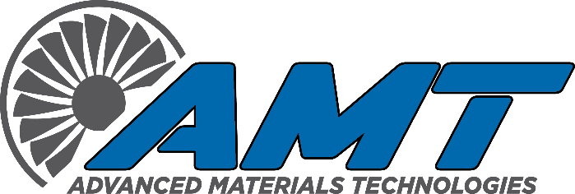
CNC Mill Set-up/Operators
Seeking motivated self-starter with 7+ year’s minimum experience.
Must have expertise with the precision machining of critical aerospace and commercial hardware including castings, and forgings ranging from aluminum to high nickel alloys. Setup and initial program validation are a must. Creating and editing programs including macros a plus. Demonstrated skill to perform inspection and validation of key features at the CNC machining center and monitoring of feeds and speeds during the machining process for optimum efficiency. Ability to adapt to changing work priorities and successfully overcoming machining obstacles. Involves collaboration with engineering/programing/management for machining optimization and fixture design
Qualifications
- Ability to set-up and run 3/4/5 axis vertical and horizontal CNC Mills with minimal supervision
- Expert skill in precision measuring equipment and use of geometric tolerancing
- Proficient ability to read blueprints, MOT’s set-up sheets and sketches
- Ability to inspect parts to verify blueprint/MOT requirements prior to first article
- Ability to properly prioritize workload based on communication from Production Control and Engineering
- Ability to determine causes of operating errors and finding solutions to the problem
- Work in a fast-paced environment
- Ability to stand for long periods of time
- Able to lift 50 pounds
- Excellent organization skills, written and verbal communication skills
- Very detail oriented
- Team player
- Positive attitude
- Must possess a competitive drive for perfect quality – system and part specific
Experience
- 7 years minimum experience
- Vertical and Horizontal CNC Mill: 7+ years (Preferred)
- High School Diploma or Equivalent (Required)
- Work authorization: United States (Required)
Job Type
- Full-time
Work Schedule
- Day Shift: 5:00 am- 1:30 pm, Monday – Friday
- 2nd Shift: 1:30 pm – 10:00 pm, Monday-Friday
- 3rd Shift: 9:45 pm – 5:15 am, Sunday-Thursday (paid 8 hours for 7 working hours)
- Overtime may be required

Pay:
- Based on experience
Pay Frequency
- Weekly
We offer a full benefits package
- Health Insurance (Employee’s premium is paid by employer at 99%)
- Dental Insurance
- Vision Insurance
- Flexible Spending Account
- 401 (k) w/company matching
- Paid Time Off (Vacation / Holiday / Sick)
This Job Is Ideal for Someone Who Is
- Dependable -- more reliable than spontaneous
- Detail-oriented -- would rather focus on the details of work than the bigger picture
- Autonomous/Independent -- enjoys working with little direction

